[**Link to Sway**](https://sway.office.com/fBNOtkJfKNBpjXIl?ref=Link)

**MCQs as a Statistics Anxiety Intervention**

**⎯⎯**

**Personal Interest**

The reasons for selecting statistics anxiety as a topic was personal. I had learned to grow out of my mathematics anxiety in secondary school but watched as my peers continued to struggle. In university, again, I watched others feel panicked when discussing statistics or coding in R to the point where some had dropped psychology. I couldn’t help but think that they needed another way to help them wrap their head around the concepts. As someone who had overcome their anxiety through hours of practising maths, I thought that the same could apply for those struggling with statistics anxiety. Hence, the research question: “Do MCQs reduce statistics anxiety in undergraduate psychology students?” was formed.

– ***Saniya J.***

**⎯⎯**

**Rationale**

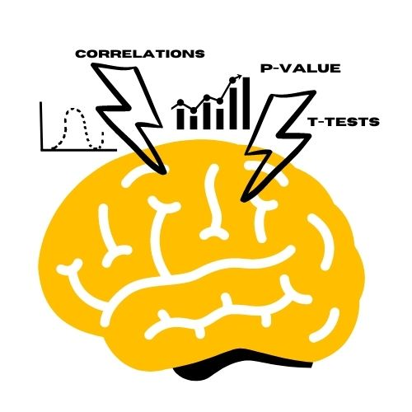Statistics anxiety refers to having any adverse reactions when discussing or approaching the topic of statistics and is a feeling that most psychology students will be familiar with. Although it may not affect performance in their statistics courses, it may result in students being less motivated to take psychology as a module or to pursue a future in the field. As such, it seemed important to find an intervention so that this wouldn’t affect students’ interest in psychology. After reviewing and evaluating existing interventions of statistics or mathematics anxiety, it was thought that formative assessments were the most effective in engaging students and improving their statistics anxiety. However, there was a lack of research around the use of multiple-choice questions (MCQs) which seemed preferable due to their short and concise approach to testing.

1 - Students can get overwhelmed by statistics concepts, causing them to have anxiety towards the topic.

**⎯⎯**

**Method**

We had decided that a method which could be applied within the confines of lecture time would be more effective so that procrastinators could be motivated to take part in the activity due to peer influence. As such, formative MCQs were developed to create a short quiz to implement immediately after a short, online statistics lecture. We hypothesised that an MCQ administered immediately after a statistics lecture would reduce statistics anxiety in undergraduate psychology students by measuring a change in scores of the Statistics Anxiety Rating Scale (STARS) from pre to post lecture.

10 participants were assigned to either a control or intervention group. All participants completed two STARS with a 17-minute lecture video on permutation tests in between each administration of the scale. The intervention group additionally completed an MCQ immediately after the lecture and before the final STARS questionnaire.

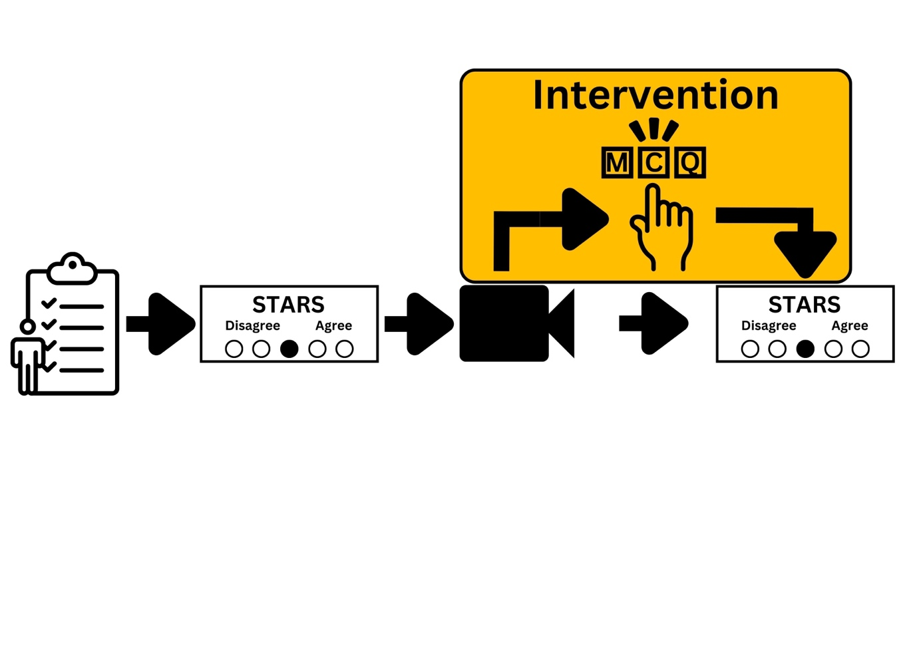

- Shows the steps of the study that all participants had to complete. In yellow is where the participants of the intervention group had deviated from the control group's process

**⎯⎯**

**Results & Discussion**

Although the hypothesis was not supported through null-hypothesis significance testing, it was assumed that it was due to sample size and certain aspects of the study’s design such as the test-retest period for the STARS. As such, it was advised that future studies implement the MCQs in a real statistics class so that the sample is more reflective, and it can be tested for a full academic year to investigate the effects of the intervention in the long term. Additionally, testing the intervention with different statistics teachers could further test its robustness against any confounding variables.

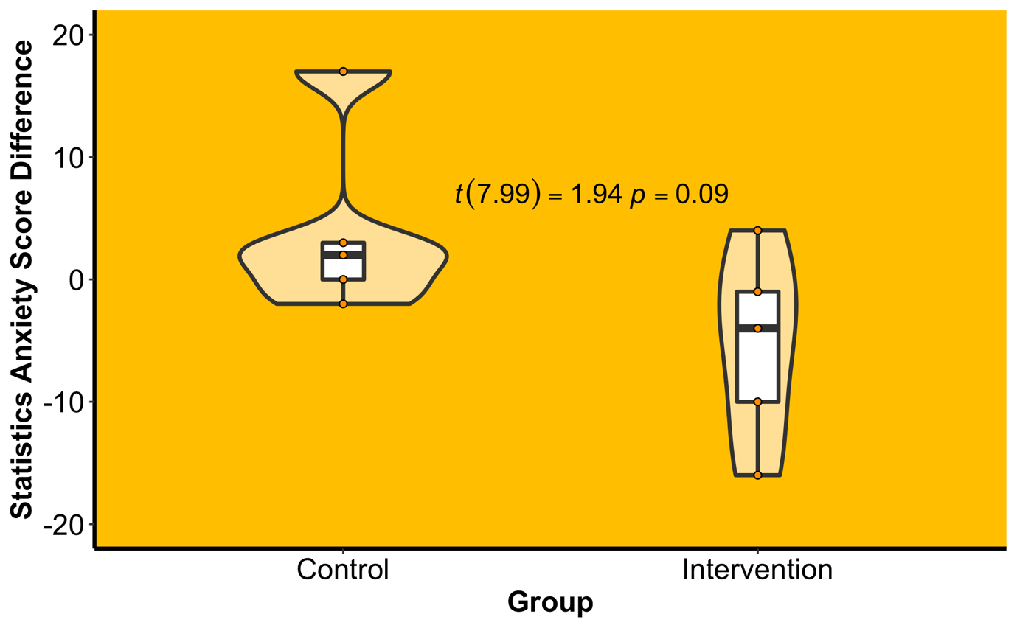

- A graph describing the results. On the y-axis is the differences of total statistics anxiety scores per participants across the pre- and post-lecture STARS questionnaire. The x-axis represents the groups.